[Doi placeholder]

*[Abstract, Invited Lecture, Progress report*]

**Title of the abstract** **[Segoe UI, bold typeface, 14pt, left alignment]**

Author name1, author name2… [Segoe UI, normal typeface, 11pt, left alignment]

1Institution name and address [Segoe UI, normal typeface, 11pt, left alignment]

2Institution name and address [Segoe UI, normal typeface, 11pt, left alignment]

*Correspondence: [Segoe UI, normal typeface, 11pt, left alignment]

**Abstract:** [Segoe UI, normal typeface, 12pt, justified, 300 words maximum]

**Keywords:** [3-5 keywords, Segoe UI, normal typeface, 12pt, justified]

# Introduction (Segoe UI, 12 pt, bold, left, intended 5 mm; one blank line after: 10 pt)

Use Segoe UI, normal typeface, 12pt, justified. There should be no spacing between paragraphs.

The length of the contributed paper is limited to 6 pages.

# Section title (Segoe UI, 12 pt, bold, left, intended 5 mm; two blank lines before and one blank line after: 10 pt)

Use Segoe UI, normal typeface, 12pt, justified. If you wish to divide a section into several smaller subsections at least two subsections should be within it.

## Subsection title (Segoe UI, 12 pt, left, intended 5 mm; blank line before: 10 pt; blank line after: 6 pt)

If you wish to divide a subsection into several smaller sub subsections at least two sub subsections should be within it.

### Sub subsection title (Segoe UI, 12 pt, italic, left, intended 5 mm; one blank line before and one blank line after: 6 pt)

Main text regarding figures (Figure 1) and tables (Table 1).

Lists in text should be in following format:

* Text Level 1
  + Text Level 2
  + Text Level 2
* Text Level 1
  + Text Level 2
  + Text Level 2
  + Text Level 2
  + Text Level 2

Figures should be centered. Add one blank line before (10 pt) and and one blank line after (6 pt) figures.

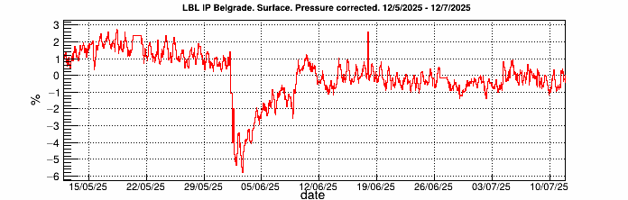

Figure 1. Figure description (Segoe UI, 10 pt, center, blank line after: 10 pt)

The width of the table should be equal to the width of the text. Table description it should be above the table with no spaces in between. Text in cells should be centered, and column and row names should be bolded.

Table 1. Table description (Segoe UI, 10 pt, left)

|  |  |  |  |
| --- | --- | --- | --- |
| Column 1 | Column 2 | Column 3 | Column 4 |
| Row 1 | x | x | x |
| Row 2 | x | x | x |
| Row 3 | x | x | x |

Add one blank line before (10 pt) table description and one blanc line after (10 pt) table.

**Acknowledgement**

[If applicable.] Use Segoe UI, normal typeface, 12pt, justified

**References**

Harvard citation style both in the reference list and in text. [https://guides.himmelfarb.gwu.edu/harvard_citation/all-examples]